**Abstract**

**COnservation of hemispheric BRAin connectivity in patients with multiple sclerosis (COBRA)**

Gerard Martí-Juana, Jaume Sastre-Garrigab, Angela Vidal-Jordanab, Sara Llufriuc, Eloy Martinez-Herasc, Sergiu Groppad, Gabriel Gonzalez-Escamillad, Maria Assunta Roccae,f,g, Massimo Filippie,f,g, Einar August Høgestølh,i, Hanne Flinstad Harboh,j, Michael A. Fosterk, Ahmed T. Toosyk, Menno M. Schoonheiml, Prejaas Tewariem, Giuseppe Pontillon,o,p, Maria Petraccaq,r, Àlex Roviraa,s, Gustavo Decot,u, Deborah Paretoa,s

**Introduction:** The mammalian brain [1], including the human brain [2], have been shown to present a conservation of hemispheric brain connectivity, with intrahemispheric brain connectivity increasing as interhemispheric brain decreases, and vice versa [1,2]. This conservation of connectivity could be disrupted in MS. In this work, we analyze the brain connectivity of 513 pwMS and 208 HC from 7 different centers, using functional (FC) and structural (SC) connectivity to study the behavior of intra/inter hemispheric connectivity in MS, and how the disease can affect it.

**Methods:** 76 cortical and subcortical areas were segmented across the brain. The corpus callosum was also segmented. SC matrices were extracted from all the subjects using fiber tracking across 76 cortical and subcortical regions. Intrahemispheric connectivity was captured with two different biomarkers: the commissural ratio, which is the ratio of fibers that pass across hemispheres compared to the total number of fibers obtained during tracking; and the corpus callosum area ratio across the midsagittal brain section. As interhemispheric connectivity, for each hemisphere, the mean shortest path length (SPL) and the efficiency were calculated separately and averaged. Those biomarkers were used to (1) reproduce the results observed in [1,2], and (2), observe any differences between healthy and pwMS on intra/inter hemispheric connectivity.

**Results:**

Conservation between intra- and interhemispheric connectivity reported in the literature is present in both HC and pwMS, across all intra/inter biomarkers computed (Figure 1), with the highest correlation being between the commissural ratio and the shortest path length (MS, r=0.68***, HC, r=0.77***). Moreover, differences between HC and RRMS, SPMS and PPMS were observed using both interhemispheric values and Efficiency. No significant differences were found in SPL. (Figure 2).

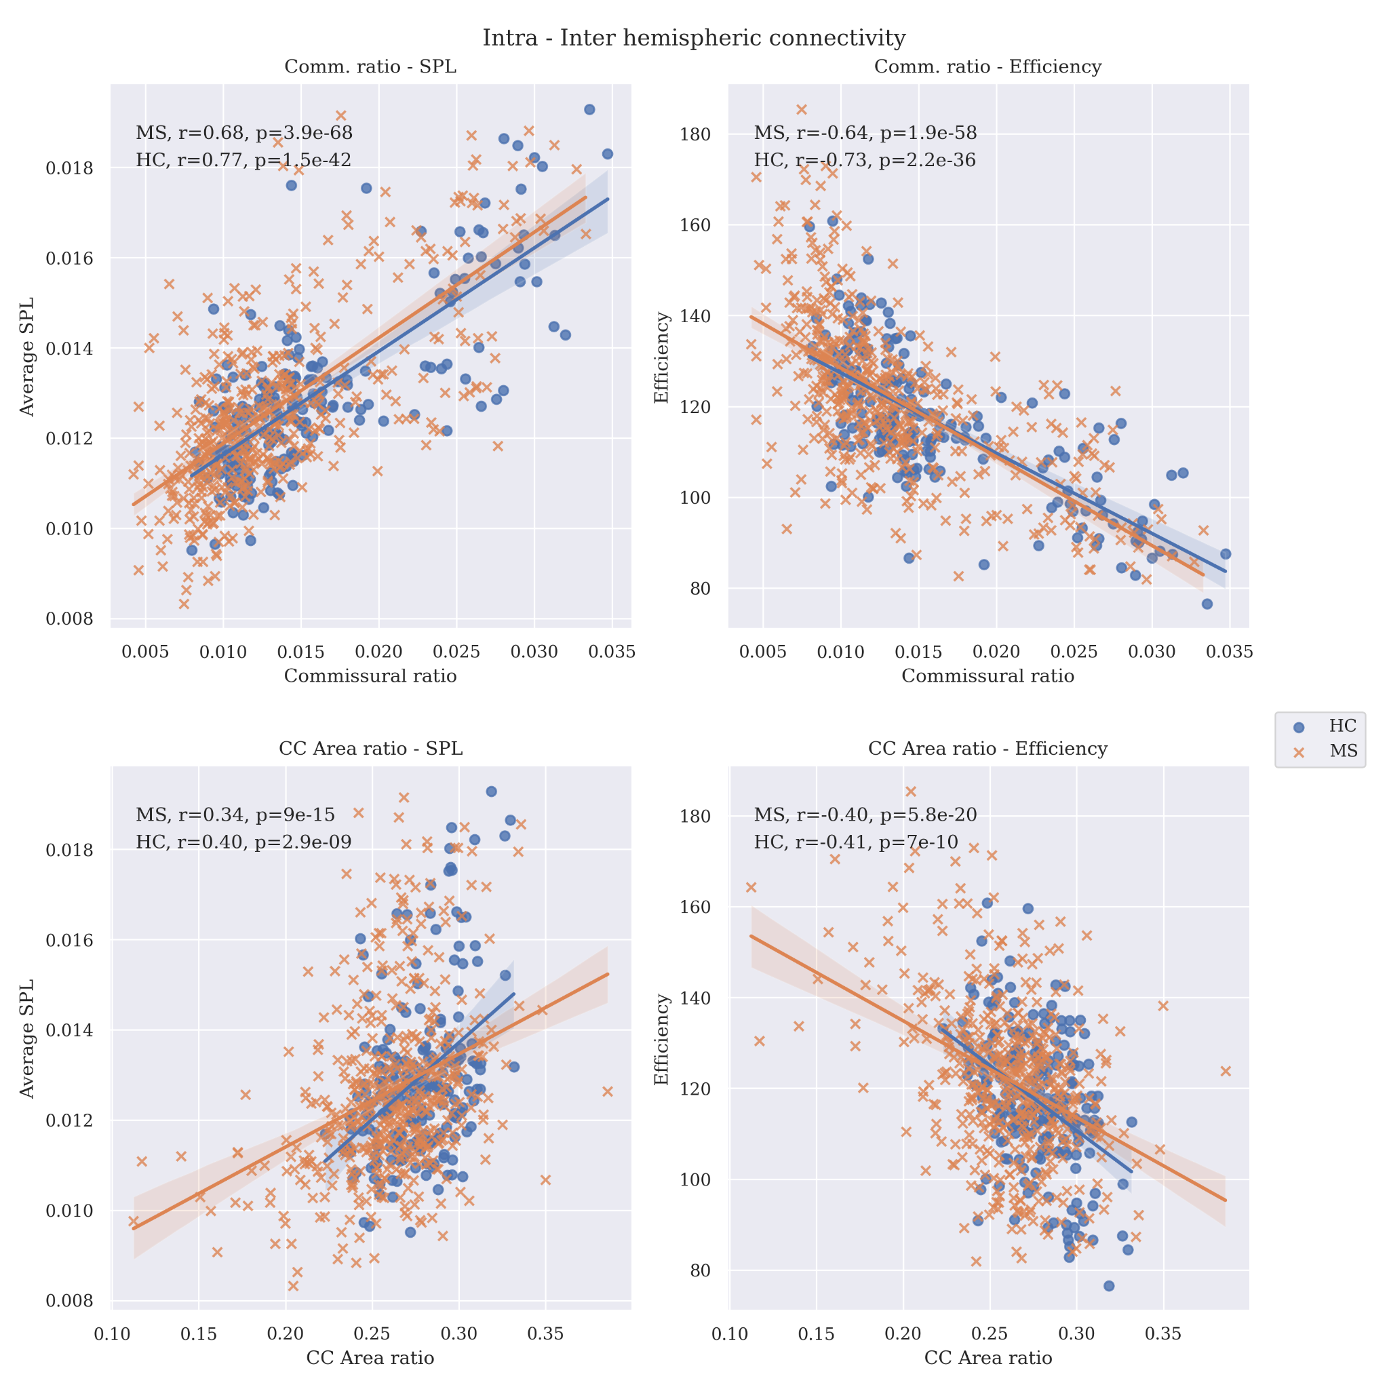

**Figure 1:** Link between intra and inter hemispheric connectivity, separated by HC and pwMS (MS in the figure). X axis represents the interhemispheric connectivity: top row represents Commissural Ratio, while the second row is the Corpus Callosum Area Ratio. Y axis represents intra hemisphere connectivity, left column being average shortest path length (SPL) and right column being average efficiency. The values are calculated separately per hemisphere and averaged.

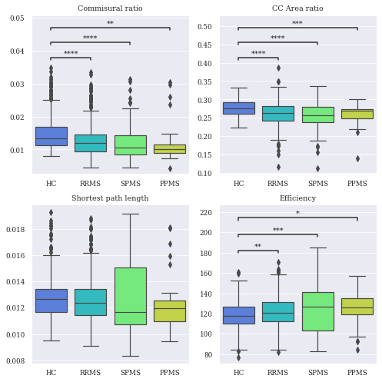

**Figure 1:** Differences across pwMS groups and HC, using various intra and inter hemispheric connectivity values.

*: p<0.05. **: p<0.01. ***: p<0.001.

**Conclusions:** While the conservation of hemispheric connectivity is not affected by MS, the associations found point to the disease affecting inter-hemispheric connections, with HC showing a higher inter-hemispheric connectivity compared to pwMS, which show a higher intra-hemispheric connectivity.

**References:**

[1] Assaf, Y., Bouznach, A., Zomet, O., Marom, A., & Yovel, Y. (2020). Conservation of brain connectivity and wiring across the mammalian class. *Nature Neuroscience*, *23*(7), 805–808. [doi.org/10.1038/s41593-020-0641-7](https://doi.org/10.1038/s41593-020-0641-7)

[2]: Krupnik, R., Yovel, Y., & Assaf, Y. (2021). Inner hemispheric and interhemispheric connectivity balance in the human brain. *Journal of Neuroscience*, *41*(41), 8351–8361. [doi.org/10.1523/JNEUROSCI.1074-21.2021](https://www.jneurosci.org/content/early/2021/08/25/JNEUROSCI.1074-21.2021/tab-article-info?versioned=true)